7. Configuring BIOS set up, Recovery, Preventive maintenance & Anti-Virus
Press and hold Del or F2 to enter setup. The key you're prompted to press might also be different; if so, use that key instead.
- You'll typically use the "F" keys to access the BIOS. These are at the top of your keyboard, though you may have to locate and hold the Fn key while pressing the proper "F" key.
- You can look at your computer model's manual or online support page to confirm your computer's BIOS key.
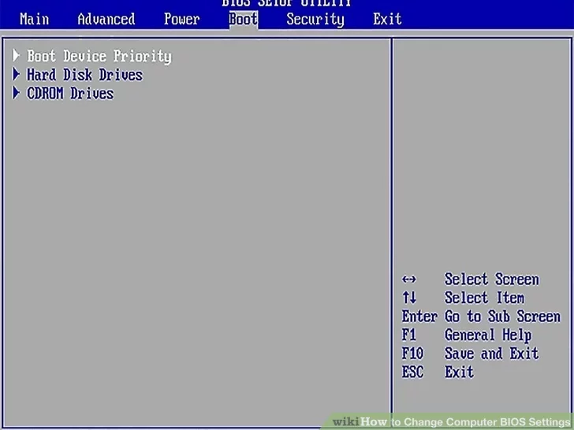
Adjust Settings
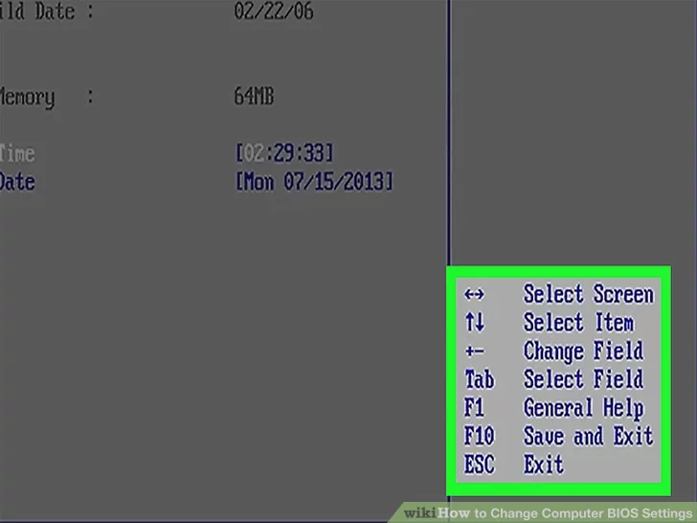
Familiarize yourself with the BIOS controls. Since BIOS menus don't support mouse input, you'll need to use the arrow keys and other computer-specific keys to navigate the BIOS. You can usually find a list of controls in the bottom-right corner of the BIOS homepage.
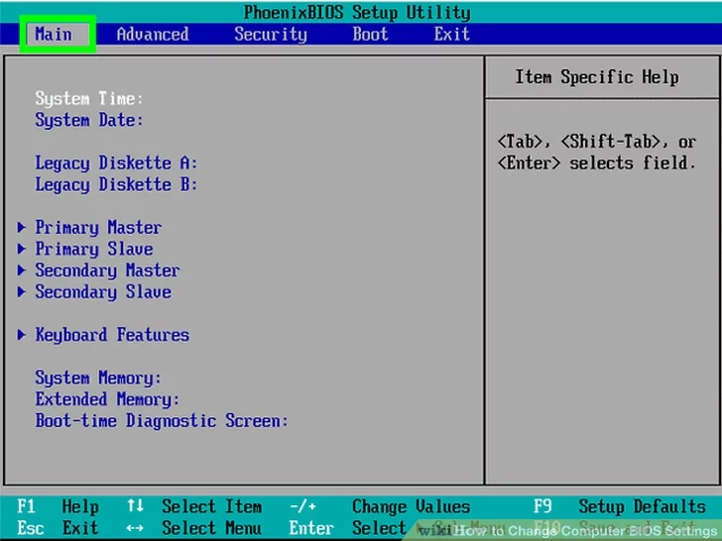
Change your settings carefully. When adjusting settings in your BIOS, be sure that you certain what the settings will affect. Changing settings incorrectly can lead to system or hardware failure.
- If you don't know what you want to change coming into the BIOS, you probably shouldn't change anything.

Change the boot order. If you want to change what device to boot from, enter the Boot menu. From here, you can designate which device the computer will attempt to boot from first. This is useful for booting from a disc or flash drive to install or repair an operating system.
- You'll typically use the arrow keys to go over to the Boot tab to start this process
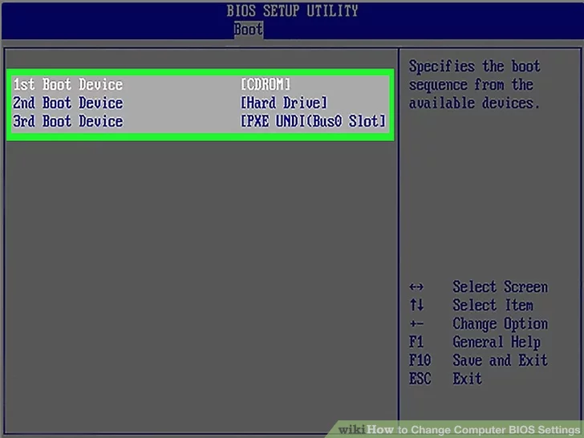
Change your date and time. Your BIOS’s clock will dictate your Windows clock. If you replace your computer's battery, your BIOS clock will most likely be reset.
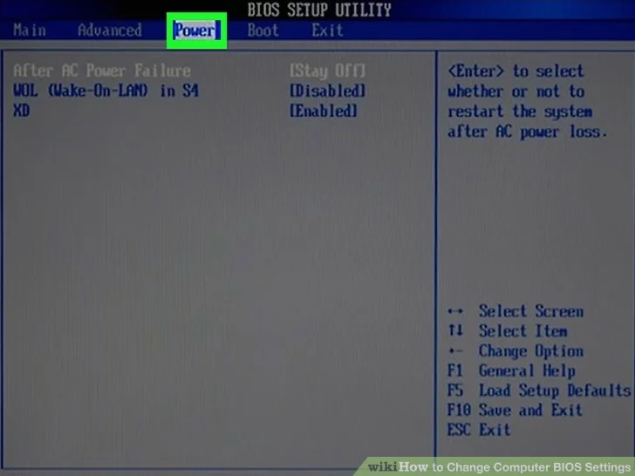
Change fan speeds and system voltages. These options are for advanced users only. In this menu, you can overclock your CPU, potentially allowing for higher performance. This should be performed only if you are comfortable with your computer’s hardware.

Save and exit. When you are finished adjusting your settings, you will need to save and exit by using your BIOS' "Save and Exit" key in order for your changes to take effect. When you save and restart, your computer will reboot with the new settings.
